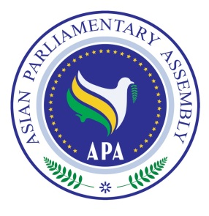
Asian Parliamentary Assembly
The 11th Plenary Session

Standing Committee on Social and Cultural Affairs
And
Meeting of APA Women Parliamentarian

30 November 2018
Istanbul – Turkey

Draft Agenda

- Adoption of the Agenda,
- Election of the Bureau,
- Opening Remarks by Chairperson of the Meeting,
- Background briefing by Dr. Ali Khorram, Deputy Secretary General of APA
- Consideration of the situation of Women Parliamentarian in Asia
- Consideration of Draft Resolutions on Social and Cultural Affairs recommended by the Executive Council
- Any other matters.

As of 27 November 2018

